
National University of Technology

Machine Learning Lab- CS3504

LAB Submitted to:

Lec.Hajra Ahmad

Submitted By:
Muhammad Abdullah

Reg. No: F22607010
Batch: Fall AI 2022
Lab : 06
Q.NO.1:
import pandas as pd
from sklearn.datasets import load_iris
import seaborn as sns
import matplotlib.pyplot as plt

# Loading the Iris dataset
data = load_iris()
df = pd.DataFrame(data.data, columns=data.feature_names)
df['species'] = data.target

df.head()
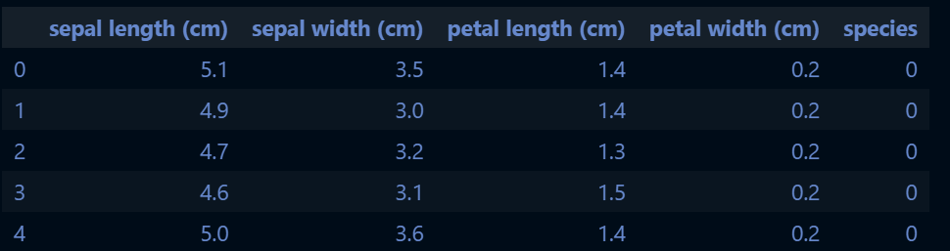
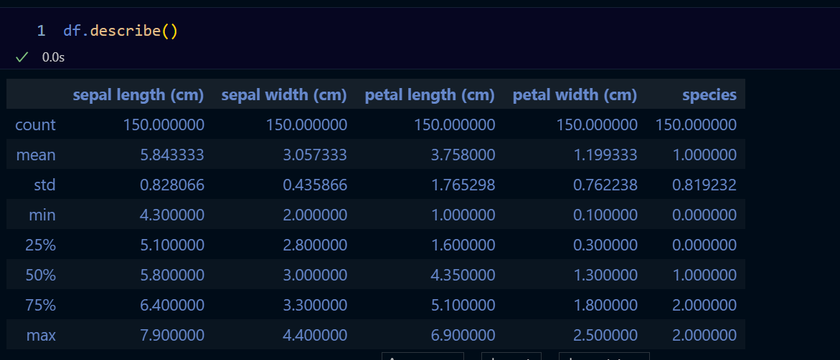

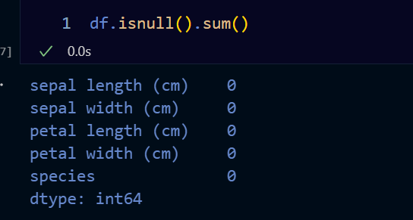

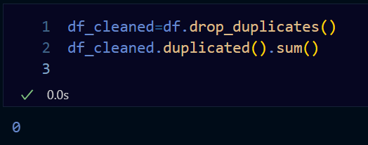

sns.pairplot(df_cleaned, hue='species', markers=["o", "s", "D"])
plt.suptitle("Pairplot of Iris Dataset", y=1.02)
plt.show()

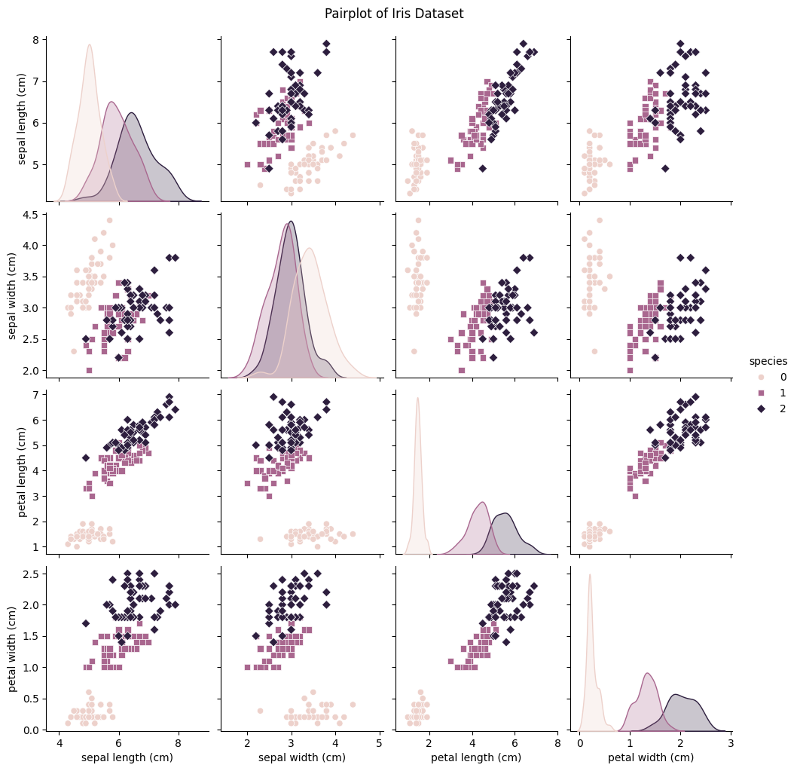
from sklearn.model_selection import train_test_split

# Defining features and target variable
X = df_cleaned.drop("species", axis=1)
y = df_cleaned["species"]

# Performing stratified train-test split
X_train, X_test, y_train, y_test = train_test_split(X, y, test_size=0.2, random_state=42, stratify=y)

print("Training set class distribution:\n", y_train.value_counts())
print("\nTest set class distribution:\n", y_test.value_counts())
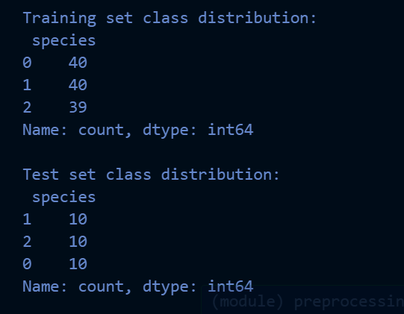

from sklearn.preprocessing import StandardScaler

# Standardizing the data
scaler = StandardScaler()
X_train_scaled = scaler.fit_transform(X_train)
X_test_scaled = scaler.transform(X_test)

from sklearn.ensemble import RandomForestClassifier

# Bagging with Random Forest
bagging_model = RandomForestClassifier(n_estimators=100, random_state=42)
bagging_model.fit(X_train_scaled, y_train)

from sklearn.ensemble import AdaBoostClassifier

# Boosting with AdaBoost
boosting_model = AdaBoostClassifier(n_estimators=50, random_state=42)
boosting_model.fit(X_train_scaled, y_train)

from sklearn.metrics import accuracy_score, classification_report

# Predictions
y_pred_bagging = bagging_model.predict(X_test_scaled)
y_pred_boosting = boosting_model.predict(X_test_scaled)

# Evaluation
print("Bagging (Random Forest) Model Accuracy:", accuracy_score(y_test, y_pred_bagging))
print("Boosting (AdaBoost) Model Accuracy:", accuracy_score(y_test, y_pred_boosting))

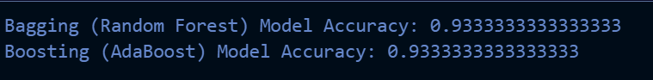

print("\nBagging Model Classification Report:\n", classification_report(y_test, y_pred_bagging))

print("\nBoosting Model Classification Report:\n",classification_report(y_test, y_pred_boosting))

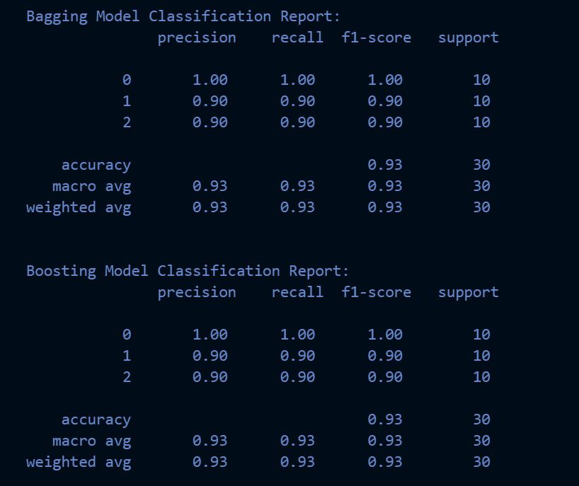

from sklearn.metrics import confusion_matrix
import seaborn as sns
import matplotlib.pyplot as plt

# Confusion matrix for Bagging (Random Forest) Model
cm_bagging = confusion_matrix(y_test, y_pred_bagging)

# Confusion matrix for Boosting (AdaBoost) Model
cm_boosting = confusion_matrix(y_test, y_pred_boosting)

# Function to plot confusion matrix
def plot_confusion_matrix(cm, title):
plt.figure(figsize=(6, 5))
sns.heatmap(cm, annot=True, fmt='d', cmap='Blues', xticklabels=data.target_names, yticklabels=data.target_names)
plt.title(title)
plt.xlabel('Predicted Labels')
plt.ylabel('True Labels')
plt.show()

# Ploting confusion matrices
plot_confusion_matrix(cm_bagging, 'Confusion Matrix for Bagging (Random Forest)')
plot_confusion_matrix(cm_boosting, 'Confusion Matrix for Boosting (AdaBoost)')

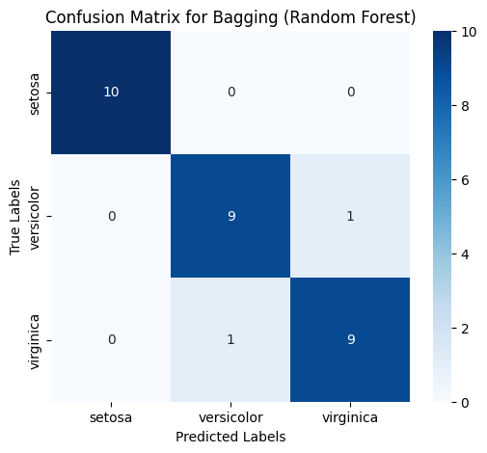

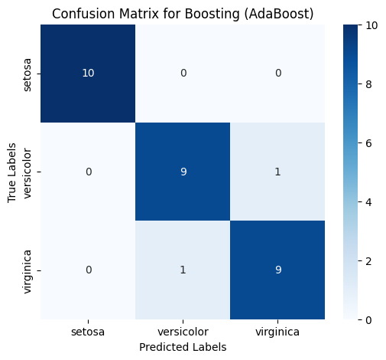

import numpy as np
from matplotlib.colors import ListedColormap

def plot_decision_boundaries(model, X, y, title):
x_min, x_max = X[:, 0].min() - 1, X[:, 0].max() + 1
y_min, y_max = X[:, 1].min() - 1, X[:, 1].max() + 1
xx, yy = np.meshgrid(np.arange(x_min, x_max, 0.02),
np.arange(y_min, y_max, 0.02))

Z = model.predict(np.c_[xx.ravel(), yy.ravel()])
Z = Z.reshape(xx.shape)

plt.contourf(xx, yy, Z, alpha=0.3, cmap=ListedColormap(('red', 'green', 'blue')))
plt.scatter(X[:, 0], X[:, 1], c=y, s=20, edgecolor='k', cmap=ListedColormap(('red', 'green', 'blue')))
plt.title(title)
plt.show()

# Usiing only the first two features for easy visualization
X_train_2d = X_train_scaled[:, :2]
X_test_2d = X_test_scaled[:, :2]

# Fiting models on 2D subset for visualization
bagging_model.fit(X_train_2d, y_train)
boosting_model.fit(X_train_2d, y_train)

# Ploting decision boundaries
plot_decision_boundaries(bagging_model, X_test_2d, y_test, title="Bagging (Random Forest) Decision Boundary")
plot_decision_boundaries(boosting_model, X_test_2d, y_test, title="Boosting (AdaBoost) Decision Boundary")



